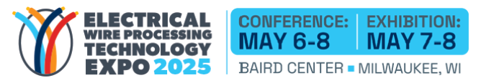

**Know Before You Go**

We look forward to seeing you at the Electrical Wire Processing Technology Expo 2025,

the industry’s premier event for wire harness manufacturing!

Here are some things to help you prepare for your visit.

**Baird Center – North Building**

All events will take place in the North Building of Baird Center, 405 W. Kilbourn Avenue, Milwaukee, WI.

**Street Level Entrance** The main street level entrance for EWPTE is on the corner of Kilbourn Avenue and N Vel R. Phillips Ave. Please do not enter the building from any other street level entrance, as access through to the North Building may not be possible. Once you enter the building, take the escalator the Level 3 and proceed to Registration, located in Exhibit Hall E.

**Hilton Guests** Enter Baird Center through the Hilton Skywalk, located on Level 4 of the hotel. Once inside Baird Center, take the single escalator down and remain on Level 2 until you reach the Skybridge, located near the South Building escalators. Cross the skybridge to enter the North Building. After you cross the Skybridge, take the escalators on your left to Level 3 and proceed to Registration, located in Exhibit Hall E.

**Hyatt Guests** Enter Baird Center through the Hyatt Skywalk, located on Level 2 of the hotel. Once inside Baird Center, immediately proceed up the escalators to your left to Level 3 and proceed to Registration, located in Exhibit Hall E.

**Parking:** The Baird Center Garage offers indoor parking with easy access to all events at Baird Center and surrounding locations. You can purchase parking passes in advance on [Baird Center’s website](https://bairdcenter.com/attendees/parking/). Please utilize the Kilbourn Avenue Entrance Garage for EWPTE. For additional parking areas or to search nearby available parking use the Interstate Parking App which is available on the Apple App or Google Play Stores.

**Registration – North Building, Third Floor, Exhibit Hall E**

Tuesday, May 6 7:00 am – 5:00 pm

Wednesday, May 7 7:00 am – 6:00 pm

Thursday, May 8 7:00 am – 2:00 pm

**VIP Express Line – *WHMA Members Only***

Exclusively for WHMA members, the VIP Express Line guarantees expedited badge pickup on site. This dedicated service streamlines the arrival process, ensuring members can effortlessly breeze through registration and swiftly access all the event has to offer. It's our way of enhancing the experience for our valued WHMA community, providing convenience and efficiency right from the moment you arrive.

**Exhibit Hall – North Building, Third Floor, Exhibit Halls D&E**

Tuesday, May 6 Exhibits Not Open

Wednesday, May 7 9:00 am – 5:00 pm

Thursday, May 8 9:00 am – 3:00 pm

**Event Schedule at a Glance**

Tuesday, May 6

8:30 am-4:00 pm Professional Development Courses | 200 Level Meeting Rooms

Wednesday, May 7

8:00 am-8:45 am Keynote Session | Room N106

Modern Technology Meets Legacy: Harley-Davidson’s Wire Harness Integration

Brian Schneider, Engineering Manager for Routed Systems, Harley-Davidson Motor Company, ***sponsored by ABB***

8:45 am Ribbon Cutting Ceremony | Exhibit Hall Entrance

9:00 am-10:00 am Networking Morning Refreshment Break | Exhibit Hall Lounge

10:00 am-4:30 pm Technical Conference Sessions | 200 Level Meeting Rooms

2:00 pm-3:00 pm Networking Afternoon Refreshment Break | Exhibit Hall Lounge

5:00 pm-7:00 pm After Hours VIP Party | Exhibit Hall Lounge | ***Sponsored by KM USA and Komax***

Thursday, May 8

8:00 am-9:00 am Networking Breakfast with Exhibitors | Exhibit Hall Lounge

9:00 am-10:00 am Networking Morning Refreshment Break | Exhibit Hall Lounge

10:00 am-2:00 pm Technical Conference Sessions | 200 Level Meeting Rooms

2:00 pm-3:00 pm Networking Afternoon Refreshment Break | Exhibit Hall Lounge

**Internet Access:** Baird Center offers free wireless internet service throughout the facility.

**Lost and Found**: Show Office, Exhibit Hall E Lobby across from Registration

**Sensory Rooms**

Baird Center sensory rooms were specially designed to create a safe, comfortable and controlled environment for people who are feeling over stimulated and need to decompress. These therapeutic spaces are located on the 200 level and rooftop level of the North Building.

**Taxis, Uber & Lyft**

Are easily accessible at the Convention Center, major hotels and other downtown locations.

**Concessions** **and Food Tents**

Located at the end of aisle 100 in the exhibit hall will be open on show days only.

**The Lounge MKE Market**

Located on the N100 street level near the Kilbourn Street entrance is an option for quick grab-to-go items including soft drinks and coffee.

**Emergency Situations:**

In the event of a serious emergency (Fire, Police, Medical), please use a house phone to contact Baird Center Public Safety to report the location and type of emergency. The public safety officer will follow up with the appropriate emergency services agency. For medical emergencies, please stay with the individual until help arrives.

**Visit WHMA/IPC | Booth 801**

* Learn how WHMA/IPC standards, education and training, advocacy, and solutions can help you and your company Build Electronics Better.
* Spin to Win:Spin the wheel for a chance to win great prizes including a WHO training course, an IPC/WHMA A-620-E Standard, an iPad, a $300 Amazon gift card, and more!
* **WHMA Membership Discount Offers:** Save 50% on your First Year’s Membership! Sign up for multiple years to save more!
* **Get a peek “under the hood” of a Harley-Davidson** Stop by to see two motorcycles on display – one fully built and ready to ride, and the other with bodywork removed to showcase the wire harness routing and electrical packaging that powers it all. This is your chance to get up close and personal with the craftsmanship that makes it all possible.

**Agenda Planner**

Get the most out of your time at EWPTE! Make your show experience more productive and efficient than ever before with the agenda planner! It’s an easy way to schedule and keep track of your activities at the show. Update your profile in just a few minutes to see attendee matches to maximize your networking. 

Log in to your [personal agenda planner](https://n1a.goexposoftware.com/events/ewpte25/goExpo/user/listSeminars.php) and start adding events, meetings, appointments along with exhibitors and products you want to see, plus much, much more:

* Export your planner/schedule to your calendar or the show app
* Find other attendees with similar interests
* Schedule appointments with other attendees and exhibitors
* Save time - use your personalized schedule as your trip report
* View EWPTE exhibitors; navigate the floor plan and plan your booth visits
* Contact exhibitors directly before the show

**Download the Official Show App** – Available for IOS and Android!

Download the official EWPTE mobile app to access and manage your schedule through the agenda planner, get the most up-to-date information on the conference, explore the show floor and to stay up to speed with the latest schedule updates to receive important text alerts.

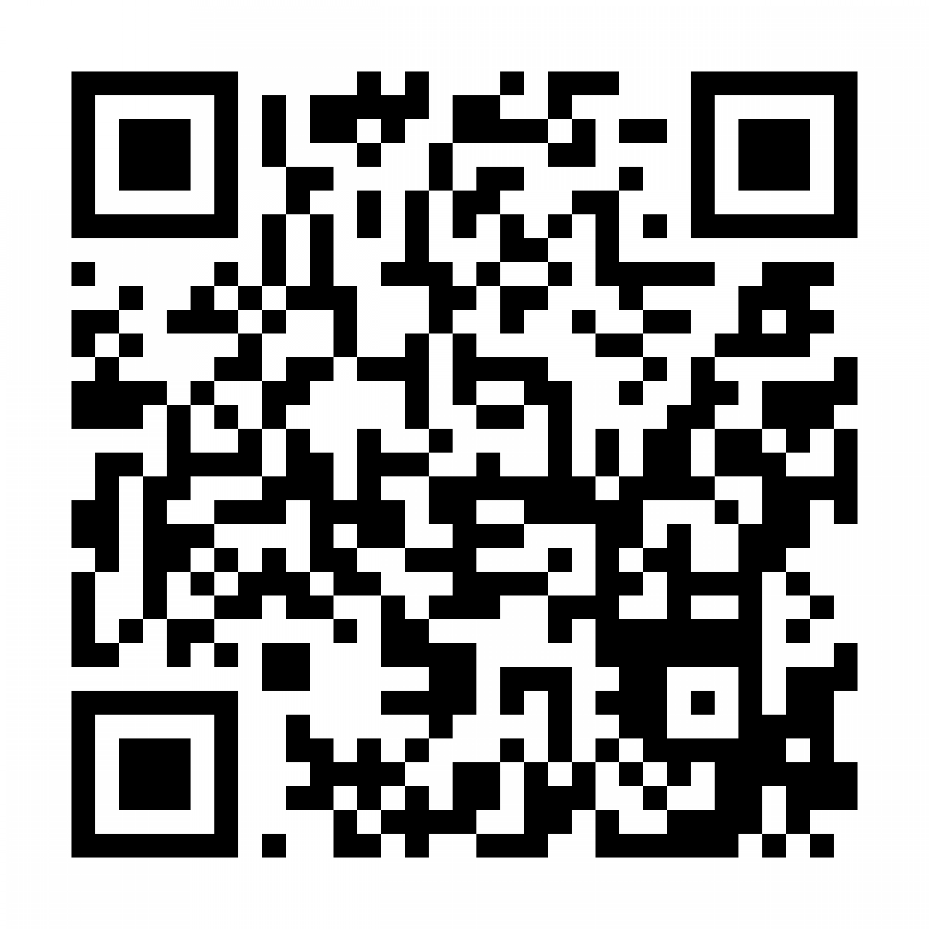

**Code of Conduct:** We believe our community should be truly open to everyone. As such, we are committed to providing a friendly, safe, and welcoming environment for all and as such, all event participants are expected to follow our [code of conduct](https://www.electricalwireshow.com/event-information/code-conduct) to ensure a positive experience for everyone.

**Suitcasing Policy:** WHMA/IPC does not permit solicitation from non-exhibiting companies. Any individual observed participating in activities to solicit or sell products to event attendees or exhibitors without having a booth at the event will be asked to leave immediately. Please report suitcasing activities to the WHMA/IPC Show Office.

**Save the Dates!**

**Electrical Wire Processing Technology Expo**

Conference: May 5-7, 2026 | Exhibition: May 6-7, 2026

Conference: May 4-6, 2027 | Exhibition: May 5-6, 2027

Conference: May 9-11, 2028 | Exhibition: May 10-11, 2028

Conference: May 8-10, 2029 | Exhibition: May 9-10, 2029

**WHMA Annual Global Leadership Summit |January 27-29, 2026 | Las Vegas, NV**

The WHMA Annual Global Leadership Summit is an executive networking conference that attracts more than 200 leaders from wire harness manufacturers, OEMs, and suppliers serving the wiring harness and cable assembly industry. The event focuses on helping executive management improve their business operations while providing valuable networking opportunities with other industry executives.

For more information visit: [annualconference.whma.org](https://annualconference.whma.org/)



